Visualization -1 (Question -1)



Know your Neighborhood

The procedure and rate of [eviction](https://en.wikipedia.org/wiki/Eviction) in the [United States](https://en.wikipedia.org/wiki/United_States) varies by locality. Landlord-initiated expulsion of tenants is not officially tracked or monitored by the Federal government and has historically not been subject to comprehensive analysis.

Eviction is a cause of poverty, as well because of it. The loss of home often results in the loss of community connections, as well as children being forced into a new school. Possessions are routinely lost, as they are placed outside on the sidewalk or placed in storage that can only be accessed by paying a fee. A legal eviction typically goes on the permanent record of the boarder, resulting in automatic rejection by other landlords or housing authorities.

Persons who are evicted lose their jobs at higher rates, either because of the new stress or because the job is no longer easily accessible in a new residence. [Mental health](https://en.wikipedia.org/wiki/Mental_health) often suffers, with one study finding that evicted mothers reported higher rates of [depression](https://en.wikipedia.org/wiki/Major_depressive_disorder) two years after being expelled.

In my analyses we will analyze evictions in the state of Massachusetts and will try to answer the most common questions about the Evictions.

Get Familiar with the Dashboard:

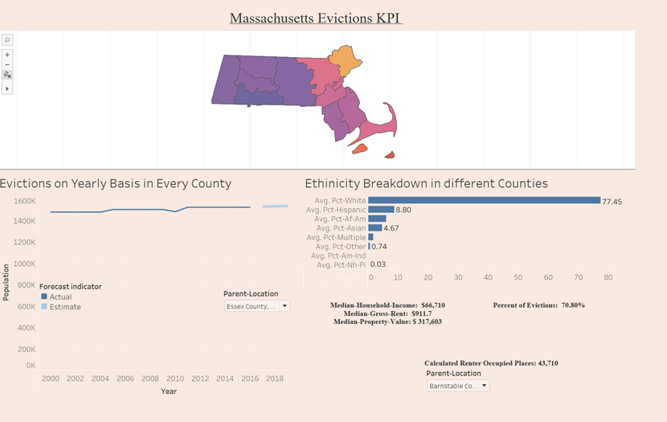

In this Dashboard we can analyze every county of Massachusetts and according different kind of ethnicity living there, total population, Gross-Rent, Median Household income and evictions on yearly basis happening in a county and in addition to that we can also see a forecast indicator which predicts the scenario of evictions in future years for any County.

Let’s analyze Evictions for a single address based on county:

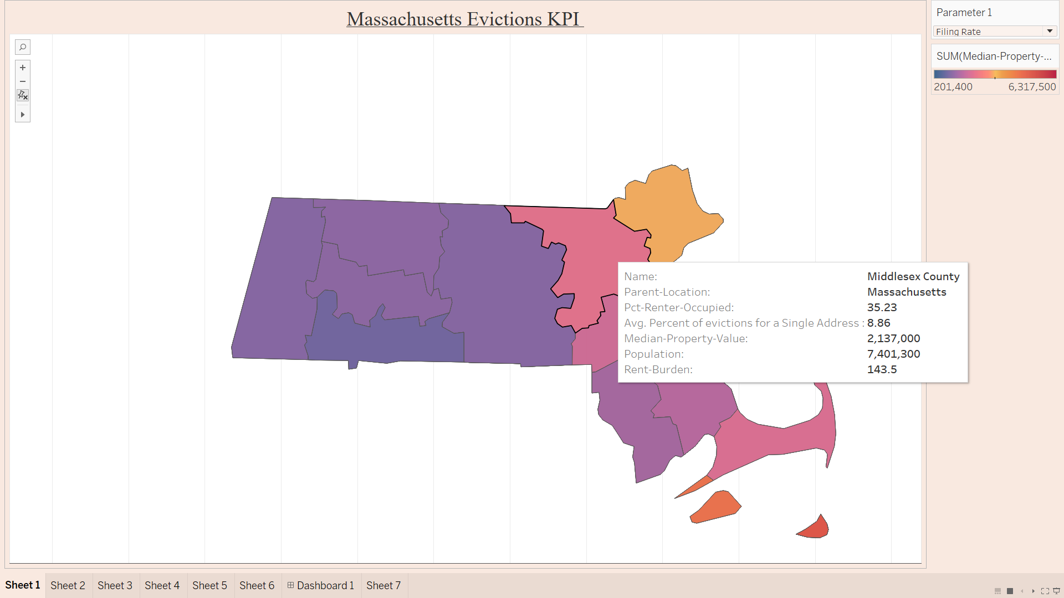

According to the graph above we can see that the maximum percent of evictions are happening in Middlesex County of Massachusetts state. There can be various reasons for this like High gross rent in that area and tenants are finding it difficult to pay rent or may be some other factor.

Lets see which County has the maximum number of People below Poverty line :

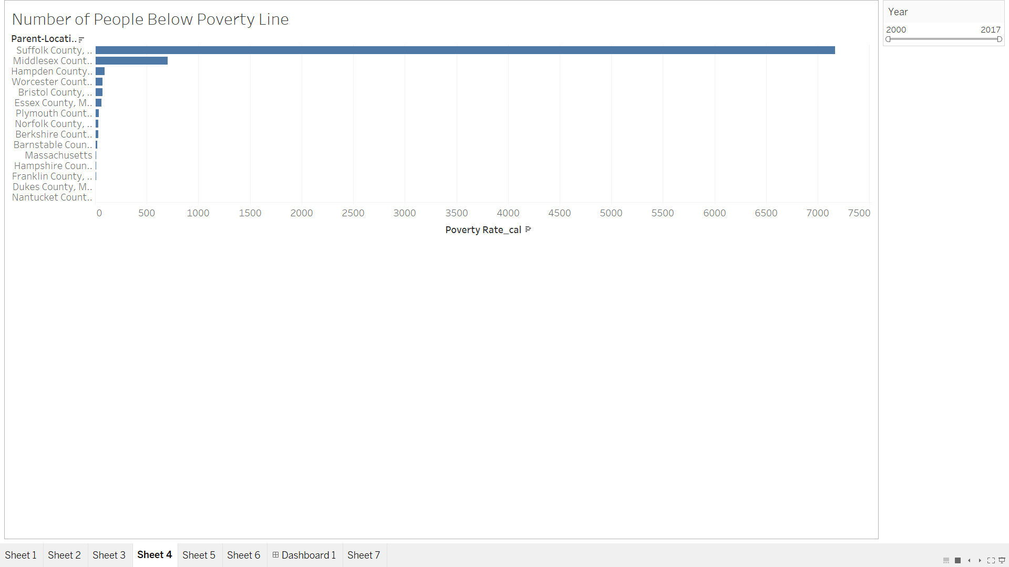

According to graph above we can see that Suffolk county has the maximum number of people who are below poverty line. This can affect the eviction rate in major way.

Let’s see eviction rate irrespective of single address or multiple:

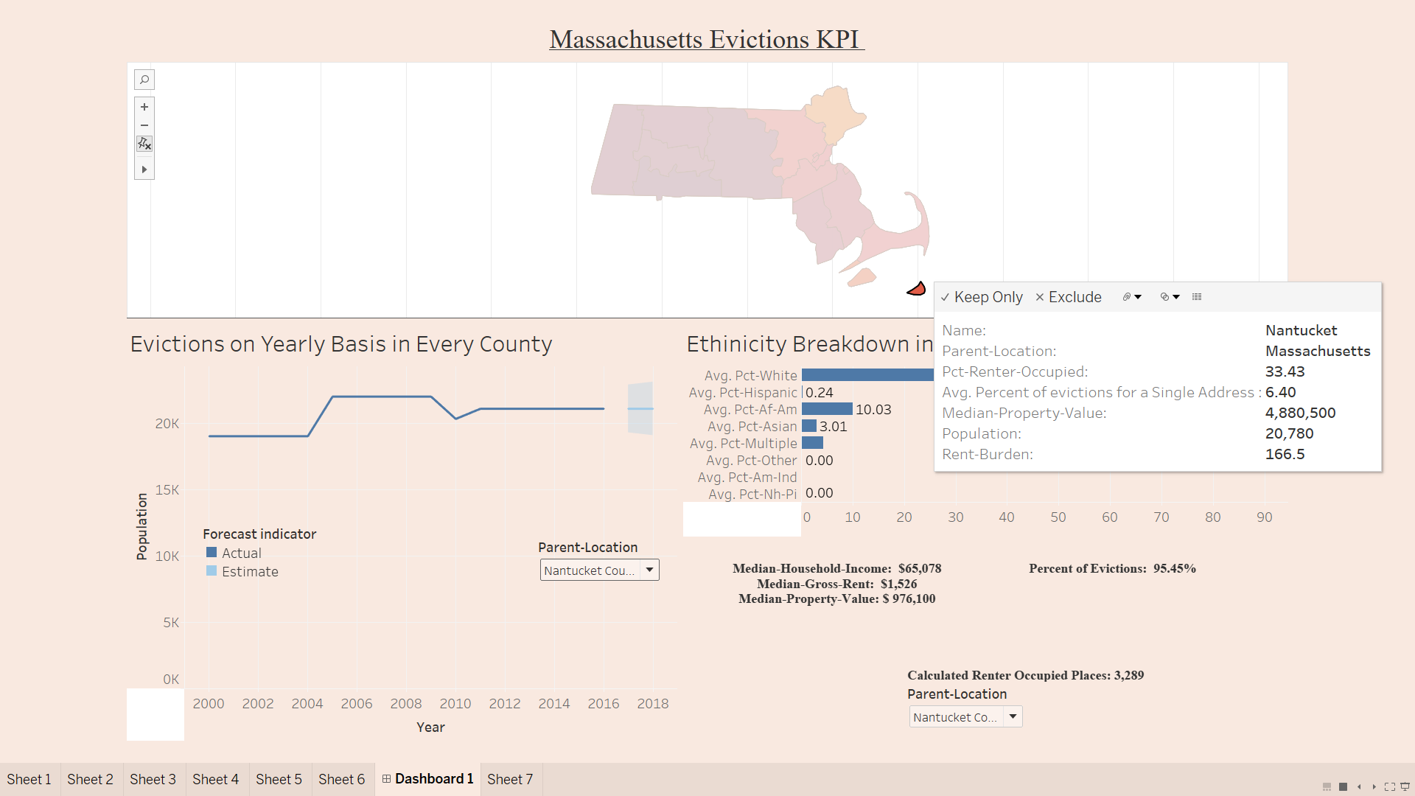

According to our visualization the eviction percentage is high in Nantucket county and median gross rent is also high in that county which is one of the main factors for evictions.

Let’s See what the trend of evictions in all over Massachusetts in the coming years will be:

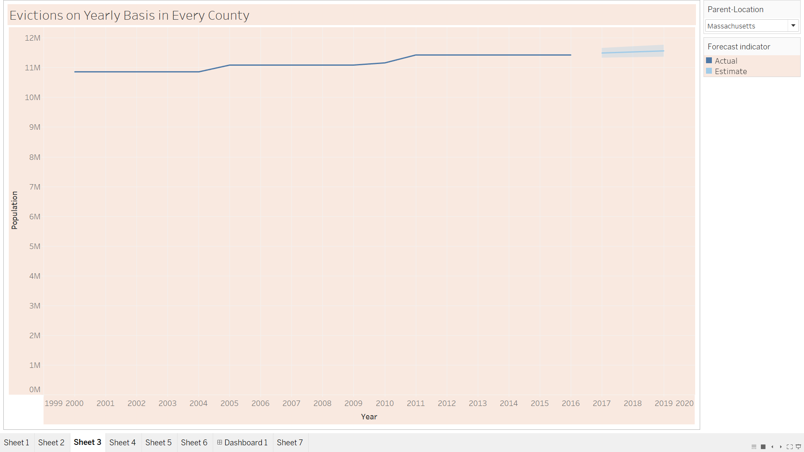

According to the graph above we can see that evictions will be increasing in the coming recent years. There is no chance of decrease in the rate of evictions.

Conclusion:

From this visualization I can say that evictions are really a big problem in almost every county of Massachusetts it is also related to gross rent and median property value. If the rent is high then there are chances that eviction will be high in that county and in the coming years there is no chance of decreasing eviction rate it will rise upwards only.